Exercise 7:
Financial Forecasting

1.Understand Recursive Algorithms:

concept of recursion and how it can simplify certain problems.
What is Recursion?
In software engineering, recursion simply means a function that calls itself. Instead of using a standard loop to repeat an action, a recursive function solves a massive problem by breaking it down into smaller, identical sub-problems until it hits a specific stopping point known as the Base Case.
- The Base Case: The condition that tells the function when to stop calling itself. Without this, the function will run infinitely and crash your program (causing a stack overflow).
- The Recursive Case: The part of the function where it calls itself with a slightly modified, smaller version of the original input.
Why Use It?
Recursion dramatically simplifies code for problems that have a naturally branching or fractal structure. If you are calculating complex compound interest, building autoregressive financial models, traversing hierarchical file directories, or navigating nested JSON data, a recursive algorithm is incredibly powerful. It can often accomplish in 5 clean lines of code what would otherwise require 50 lines of complex, error-prone loop management to do.

2. Setup:
build a "Viral Growth" forecasting model. Assume our company's new user acquisition for the current month is directly driven by the combined momentum of the previous two months.
Fibonacci sequence: Forecast(n) = Forecast(n-1) + Forecast(n-2)
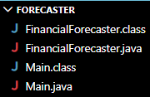

3.Implementation:
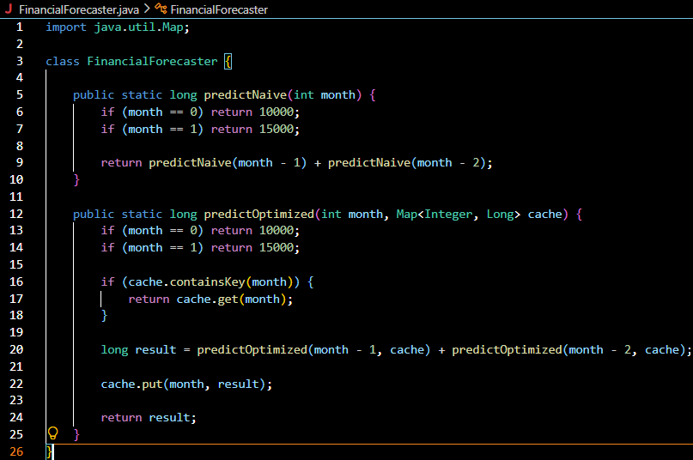
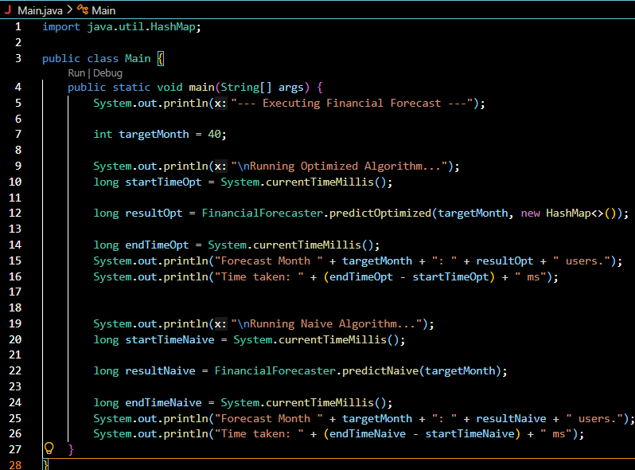

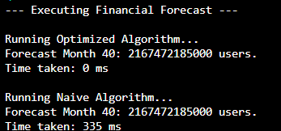

4.Analysis:
Algorithm | Time Complexity
Naive Recursion | $$O\left(2^{n}\right)$$
Optimized Recursion | $$O\left(n\right)$$

The primary issue with a basic recursive approach is the occurrence of overlapping subproblems. For example, if you ask a computer to calculate the financial growth for Month 5, the function needs to calculate Month 4 and Month 3. However, to calculate Month 4, it also has to calculate Month 3 and Month 2.
Suddenly, the computer is calculating the exact value for Month 3 multiple times. As the input size grows, this inefficiency balloons exponentially, forcing the system to perform millions of duplicate calculations.
To fix this, we use an optimization technique called Memoization (derived from the word "memo"). By passing a data structure like a HashMap (acting as a cache) into the recursive function, we force the function to check its data store before executing any math. If it already calculated Month 3 a few milliseconds ago, it simply pulls that answer directly from the map, skipping the redundant work entirely.
This shift turns an inefficient, slow process into a fast operation by ensuring that every unique subproblem is only solved exactly once.

